

Princess Sumaya University for Technology

King Abdullah II School of Engineering

Computer Engineering Department

Embedded Systems – 22442

Final Project Report

AgriBot: An Agriculture Robot

Instructure: Prof. Belal Sababha

Supervisor: Eng. Saad Al-Zoubi

Sarah Al-Shobaki 20220188

Abdulrahman Atassi 20210651

Maryam Al-Omar 20210885

*May 2025*

***Abstract***

*The AgriBot project focuses on developing an autonomous, Bluetooth-controlled robotic system designed for efficient lawn maintenance and smart irrigation. The robot integrates multiple functionalities, including grass cutting via DC motor-driven blades, real-time soil moisture monitoring using dedicated sensors, and automated irrigation controlled by an onboard water pump. A rain sensor ensures the system halts watering operations during rainfall, optimizing water usage. This report provides a comprehensive overview of the design, implementation, testing, and performance of AgriBot, highlighting its potential to simplify garden care and promote sustainable water management. Testing confirmed the system’s ability to perform remote operation, autonomous navigation, and responsive environmental adaptation, demonstrating AgriBot’s potential for use in both residential and agricultural settings.*

Table of Contents

1 Introduction 4

1.1 Theory 4

1.2 Objectives 5

2 Design 6

2.1 Hardware Design 6

2.2 Software Design 8

3 Results 10

4 Challenges and Recommendations 10

5 Conclusion 11

6 References 11

## 1 Introduction

Maintaining healthy lawns and gardens requires consistent effort in mowing and irrigation, tasks that can be both time-consuming and resource intensive. With the growing demand for automation in daily life and a greater focus on sustainability, the need for smart gardening solutions has become increasingly relevant. The AgriBot project addresses this need by introducing a multifunctional robotic system capable of autonomously managing lawn care while optimizing water usage.

AgriBot is designed to operate with minimal human intervention, offering features such as automated grass cutting, real-time soil moisture monitoring, and intelligent irrigation control. The robot is equipped with DC and Servo motors to drive its cutting mechanism, soil moisture sensors for environmental awareness, and a water pump that activates only when necessary. Additionally, a rain sensor ensures that the system conserves water by halting irrigation during rainfall. For added convenience and user control, AgriBot can be operated remotely via Bluetooth using a smartphone.

### Theory

The foundation of the AgriBot project lies in the integration of robotics, environmental sensing, and smart irrigation technologies. Robotics has become a powerful tool in automating routine agricultural and domestic tasks, providing reliable and efficient solutions that reduce manual labour. By combining mechanical components with intelligent control systems, robots can perform complex functions such as navigation, obstacle avoidance, and task-specific operations like cutting grass or watering plants.

Environmental sensing plays a critical role in enabling robots to interact intelligently with their surroundings. In agricultural and gardening contexts, soil moisture levels are a key factor influencing plant health and growth. By using soil moisture sensors, robotic systems can collect real-time data to make informed decisions about irrigation needs. This not only ensures optimal plant hydration but also minimizes water wastage which is an increasingly important consideration in the face of global water scarcity.

Smart irrigation systems leverage sensor feedback to automate the watering process based on environmental conditions. These systems typically include water pumps, control circuits, and microcontrollers that activate irrigation only when moisture levels fall below a certain threshold. The addition of a rain sensor further enhances efficiency by preventing unnecessary watering during rainfall, conserving water and avoiding over-irrigation.

In AgriBot, the fusion of these technologies is managed by a central microcontroller that interprets sensor data and controls the robot’s motors, cutting mechanism, and irrigation system. Bluetooth communication adds a layer of user-friendly wireless control, allowing the robot to be operated remotely via a smartphone. This combination of automation and smart decision-making enables AgriBot to maintain lawns effectively while promoting sustainable resource usage.

### Objectives

1. **Grass Cutting:** The robot is equipped with DC motors that drive a cutting mechanism, efficiently mowing the grass to maintain a fixed height.
2. **Soil Moisture Monitoring**: Using soil moisture sensors, the robot constantly tracks the water levels in the soil.
3. **Automated Irrigation**: The robot features a water pump operated by its internal system. Utilizing real-time data from the soil moisture sensor, when the humidity falls beneath a predetermined level, the robot starts watering the grass.
4. **Wireless Control via Bluetooth**: The robot is easily manageable through a smartphone due to the incorporation of a Bluetooth module, as this provides flexibility to the users.
5. **Automatic Stop**: The automatic irrigation system stops whenever it rains. This happens due to the existence of a rain sensor.

## Design

The design of AgriBot centre around the seamless integration of hardware and software components to achieve autonomous lawn maintenance and smart irrigation. Key elements include the cutting system, moisture sensing unit, water pump, rain sensor, and Bluetooth control module. This section details the structural layout, component selection, and interaction between system modules to ensure efficient performance.

### Hardware Design

The hardware design of AgriBot integrates multiple components to enable smooth and efficient operation. Here is an overview of them:

1. **Microcontroller (PIC 16F877A)**

Acts as the core controller, managing signals from sensors, actuators, and Bluetooth communication. Processes accelerometer data to control the robotic vehicle's movements and handles obstacle detection and feedback mechanisms.

1. **DC Motors**

AgriBot uses a total of five DC motors to carry out its core functions. Four of these motors are individually connected to each wheel, enabling stable and controlled movement across the lawn for both watering and cutting tasks. The fifth motor is dedicated to powering the grass-cutting mechanism, ensuring consistent and efficient mowing during operation.

1. **Servo Motor & Soil Moisture Sensor**

The soil moisture sensor measures soil humidity, but instead of remaining fixed, it is moved by a servo motor. The servo lowers the sensor into the soil when readings are needed, then lifts it back up, allowing for mobility and protection during operation.

1. **Ultrasonic Sensor**

The ultrasonic sensor is used for obstacle detection, helping AgriBot navigate safely through the lawn. It measures the distance to nearby objects and alerts the system to stop or change direction to avoid collisions.

1. **Touch Sensor**

The touch sensor functions as a rain detector. When rain is detected, it signals the system to immediately stop the watering operation, preventing over-irrigation and conserving water.

1. **Power Supply**

Three 3.7V batteries provide stable power to all components.

1. **Switches**

AgriBot includes power ON/OFF and reset buttons for user control. The power switch activates or shuts down the system, while the reset button restarts the microcontroller, allowing quick system reinitialization when needed.

1. **Bluetooth Module**

The Bluetooth module enables wireless communication between AgriBot and a smartphone. It allows the user to remotely control movement, monitor status, and manually activate functions such as watering or mowing.

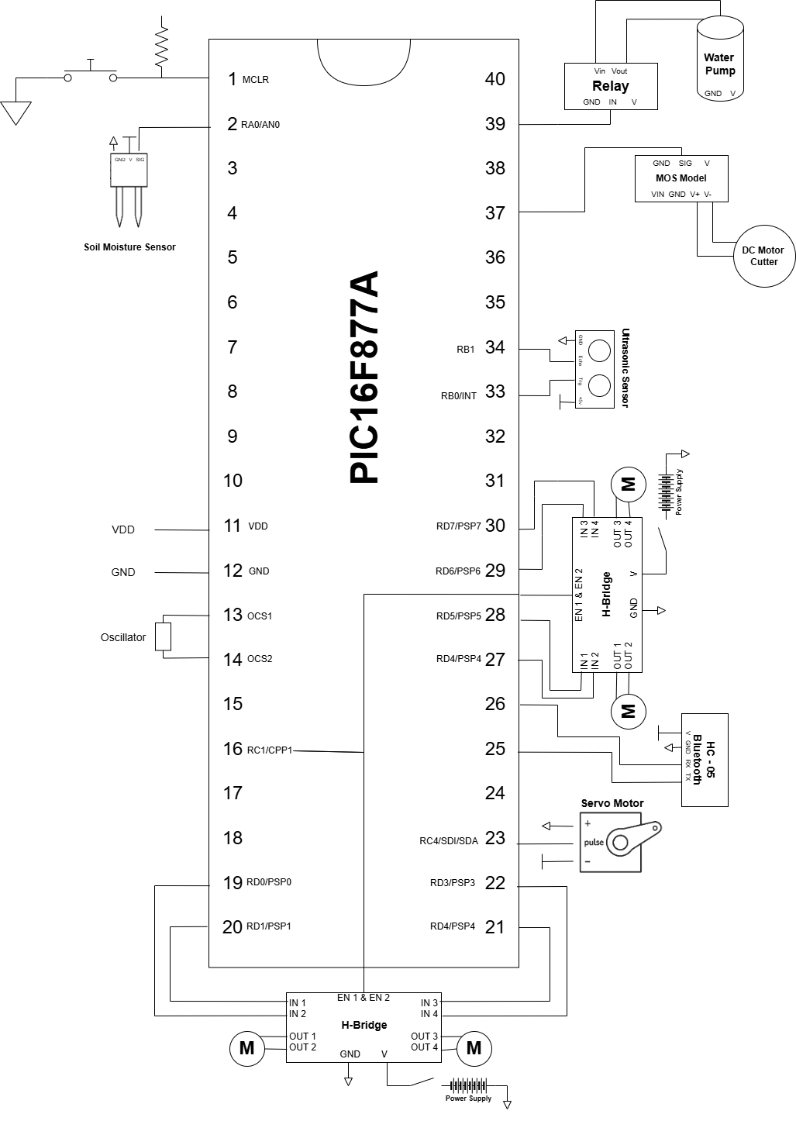

Figure Block Diagram

### Software Design

The software design for AgriBot is centred on autonomous agricultural operations and efficient control of its hardware components. A key feature is the implementation of PWM (Pulse Width Modulation) control for DC motors using dual L298N motor drivers, enabling precise speed control for navigation and agricultural tasks. The system processes Bluetooth commands to adjust PWM duty cycles dynamically through the CCP2 module, ensuring smooth and accurate motor speed adjustments for movements such as forward, backward, left, and right turns with speeds ranging from 100-150 PWM values.

The software integrates multiple control modes—Bluetooth-based remote control and autonomous obstacle avoidance—allowing seamless operation between manual agricultural tasks and automated navigation. Real-time responses are achieved through UART communication at 9600 baud rate for processing remote commands, ultrasonic sensor measurements for obstacle detection, and interrupt-based servo control using CCP1 compare mode for precise angular positioning.

The HC-SR04 ultrasonic sensor enhances safety by continuously monitoring distances and automatically stopping motors when obstacles are detected within 10 cm, preventing collisions during field operations. The servo motor control system provides 0-360 degree rotation capability for agricultural implements, utilizing Timer1-based PWM generation with 0.5ms to 2.5ms pulse width modulation for accurate positioning.

Agricultural functionality is implemented through integrated soil moisture sensing using ADC conversion on channel 0, with automatic irrigation control via relay-activated water pump based on moisture threshold values above 500 ADC counts. The cutter mechanism is controlled through dedicated GPIO pins for crop harvesting operations, while the entire system maintains robust operation through proper initialization routines, timeout mechanisms for sensor readings, and fail-safe motor control ensuring reliable autonomous agricultural vehicle operation.

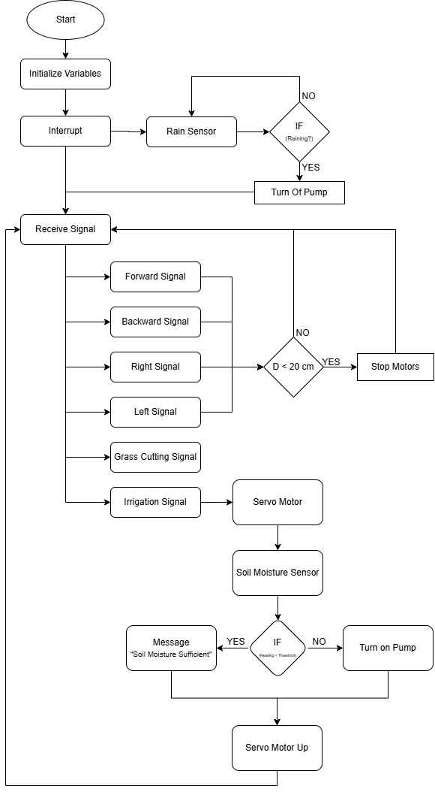

Figure Flowchart

## 3 Results

AgriBot successfully performed autonomous lawn maintenance tasks with minimal user intervention. The automated grass cutting mechanism operated efficiently across various terrains. Soil moisture sensors monitored conditions, triggering the water pump only when necessary. The rain sensor effectively prevented irrigation during rainfall, conserving water. Remote control via Bluetooth was reliable, allowing seamless user interaction through a smartphone app. Overall, AgriBot demonstrated improved water efficiency, reduced manual labour, and consistent lawn care performance.

## 4 Challenges and Recommendations

During the development and testing of the AgriBot system, the team encountered several technical and logistical challenges that impacted the implementation timeline and feature set. These challenges, along with recommendations for future improvement, are outlined below:

1. **Incomplete Rain Sensor Interrupt Integration**

One of the intended features was to have the rain sensor operate through an interrupt mechanism to instantly halt irrigation during rainfall. However, due to time constraints and prioritization of core functionalities, this feature was not implemented.   
**Recommendation**: In future versions, configure the rain sensor with an external interrupt pin on the microcontroller to ensure immediate and energy-efficient response to rainfall events.

1. **Bluetooth Control Responsiveness**

While Bluetooth-based control was functional, occasional delays in command execution were observed, particularly when multiple commands were sent in quick succession. This was likely due to limitations in serial communication handling and buffer overflow.  
**Recommendation**: Improve the Bluetooth communication protocol by implementing a robust state machine and command queue and consider using interrupt-driven UART to avoid data loss.

1. **Soil Sensor Calibration**

The soil moisture sensor readings occasionally showed inconsistencies depending on soil density and placement depth. These variations affected irrigation accuracy.  
**Recommendation**: Perform multi-point calibration under different soil conditions and add software-based filtering or averaging to improve reliability. Alternatively, investigate the use of capacitive soil sensors for more stable readings.

1. **Limited Power Efficiency**

AgriBot relied on three 3.7V batteries, which limited operational time and required frequent recharging, especially when the pump and motors were active simultaneously.  
**Recommendation**: Explore energy optimization strategies such as motor PWM control, sleep modes for idle components, or even integrating a small solar charging system for sustainable outdoor use.

## 5 Conclusion

The AgriBot project successfully demonstrates the integration of embedded systems, robotics, and smart agriculture in a single multifunctional platform. Using a PIC16F877A microcontroller, various sensors, motors, and wireless communication modules, AgriBot efficiently performs essential lawn care tasks including grass cutting and irrigation. The robot responds to real-time environmental inputs—such as soil moisture levels and rainfall—ensuring resource-efficient operation and promoting sustainability.

These capabilities make AgriBot a promising solution for both residential gardens and small-scale agricultural applications. While the system performed reliably during field tests, future improvements may include solar power integration for energy sustainability, GPS navigation for broader coverage, and the use of machine learning to further optimize irrigation patterns. Overall, AgriBot stands as a practical step toward smarter, automated, and environmentally conscious agricultural tools.

## 6 References

* Mazidi, M. A., Mazidi, J. G., & Causey, R. D. (2005). *PIC Microcontroller and Embedded Systems: Using Assembly and C for PIC18*. Pearson Education.
* Stipanicev, D., & Marasovic, J. (2003). *Networked Embedded Greenhouse Monitoring and Control*. Proceedings of the IEEE Conference on Control Applications.
* Hasan, M. K., et al. (2020). *Smart Agriculture Monitoring System Using IoT*. *International Journal of Engineering Research & Technology*, 9(5), 406–409.
* Texas Instruments. (2022). *DC Motor Control Fundamentals*. Retrieved from <https://www.ti.com>
* Microchip Technology Inc. (2023). *PIC16F877A Datasheet*. Retrieved from <https://www.microchip.com>
* Raut, R. D., Gardas, B. B., & Narkhede, B. (2017). *Smart Irrigation: Water Management Using Wireless Sensor Networks*. *Journal of Environmental Management*, 204(Pt 1), 91–100.
* Arduino Project Hub. (n.d.). *Bluetooth Controlled Robot*. Retrieved from https://create.arduino.cc

GitHub: <https://github.com/abdulrhmanAtassi/AgriBot-Embedded>

YouTube: